22 September 2023

Dear Parent/Carer

We are delighted with the way the Year 9 students have settled into life at college. Thank you for your support in ensuring they are in perfect uniform and arriving to college on time.

We hope that you have all logged into class charts so that you can see all the achievement points that are being awarded each day, some students may have acquired a few behaviour points but not as many as the achievement points. Class charts is also where you can find out the homework that is being set and the day it is due. If you have had any issues with logging in, please contact the IT Support Team at fccitteam@fromecollege.org

Following a parent voice survey in the summer term, some families asked about curriculum maps. The overall map of the year can be found on our website. Curriculum maps In addition here is the most up to date map just for this term. Yr9 term 1 (1).docx

As you know this year, we have changed the Year 9 curriculum, with students only opting for 1 GCSE subject. There was not going to be an option change window, however, there are some students who have been requesting an option change and therefore you can request this by completing the online form by 1pm on Friday 29 September 2023. Request option change. Please still complete this online form even if you have already been in touch about course changes.

Finally, attendance to school is key to a student’s success. Please where possible ensure appointments are made outside of school hours or at the start/end of the day so that students can still attend most of their learning.

We very much look forward to welcoming you on Thursday 19 October 2023 to meet the tutor, if you do have any questions before then please contact your child’s tutor in the first instance.

Yours sincerely
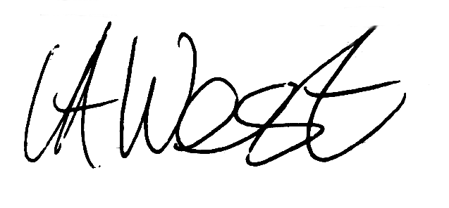

Mrs Vicky West
Assistant Principal
Raising Achievement Lead for Year 9

